Measure Double and Triple Bottom Line
To measure the Double Bottom Line (profit + people) or Triple Bottom Line (profit + people + planet), social entrepreneurs use clear frameworks.
Let us explore each one by one:

1. Key Performance Indicators (KPIs)
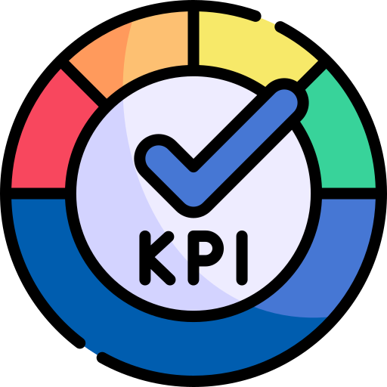
What is it?
KPIs are specific, trackable metrics that show whether you are meeting your goals. They are quantitative, easy to communicate, and tailored to each project.
https://www.flaticon.com/free-icon/kpi_9086371?term=kpi&page=1&position=4&origin=search&related_id=9086371
Formula/Format:
No single formula. KPIs are tracked as unit metrics, like:
- Number of lives impacted
- Tons of plastic recycled
- Hours of training delivered
- Households with clean drinking water
Example:
Project: An NGO installs purifiers in 20 villages.
KPIs:
- People with access to clean water: 10,000
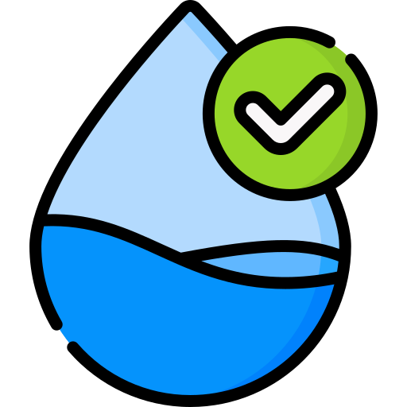
- Water-borne illness cases reduced: 70%
- Litres of clean water delivered per day: 2 lakh L/day
KPIs make it easy to track change and communicate impact to stakeholders.
https://www.flaticon.com/free-icon/quality_5882986?term=clean+water&page=1&position=9&origin=search&related_id=5882986

2. Social Return on Investment (SROI)
What is it?
SROI quantifies how much social or environmental value is created for every rupee invested. It's like ROI, but for social change.
Formula:
SROI = Total Social Value Generated ÷ Total Investment Made

Social value could include: income increase, cost savings, better health, environmental benefit—all converted into Rupee terms.
Example:
https://www.flaticon.com/free-icon/classroom_906175?term=training&page=1&position=13&origin=search&related_id=906175
Project: Training 100 rural women to make eco-friendly sanitary pads
Investment: Rs 10 lakhs/year
Outcomes:
- Rs 5 lakhs income gain
- Rs 3 lakhs healthcare savings
- Rs 2 lakhs in environmental waste management savings
Total value = Rs 10 lakhs
SROI = Rs 10L / Rs 10L = 1.0
For every Re 1 spent, Re 1 of social value is created.
In later years, if value increases to Rs 17 lakhs:
SROI = Rs 17L / Rs 10L = 1.7

3. The B Impact Assessment (BIA)

What is it?
A global standard used to evaluate a company’s performance across social, environmental, governance, and community metrics. Widely used by Benefit Corporations.
https://www.flaticon.com/free-icon/evaluation_18609615?term=survey+tool&page=1&position=92&origin=search&related_id=18609615
Format:
- Conducted via a comprehensive survey tool
- Scores are given in categories like:
  - Governance
  - Workers
  - Community
  - Environment
  - Customers
- Final score out of 200
- Need 80+ to qualify for B-Corp Certification

Example:
Company: A startup making solar lamps for rural areas.
https://www.flaticon.com/free-icon/street-lamps_2886724?term=solar+lamps&page=1&position=3&origin=search
Assessment covers:
- Ethical sourcing of materials
- Fair wages and training to employees
- Off-grid community impact
- Recycling processes
It scores:
- Governance: 15
- Workers: 18
- Community: 22
- Environment: 25
- Customers: 10
Total: 90/200
To be eligible for the BIA, the score should be at least 80 out of 200 points.
Here, in the example, the score is 90, so the company is eligible for B-Corp Certification.
BIA provides a 360° audit of DBL and TBL values using globally accepted benchmarks.

4. Impact Reports
What is it?
Impact reports are published annually to showcase how a project or enterprise is delivering on social, environmental, and financial goals. Think of it as an annual report, but focused on impact.
Format:
No fixed formula, but includes:
- KPIs, SROI, case studies
- Visual storytelling (before-after data, testimonials)
- Alignment with SDGs or ESG goals
- Challenges, learnings, and roadmap
https://www.flaticon.com/free-icon/storytelling_12914694?term=storytelling&page=1&position=66&origin=search&related_id=12914694
Example:
Organisation: A skilling foundation for urban youth
Annual Impact Report Includes:
- 10,000 youth trained
- 70% placed in jobs
- Average salary increase: Rs 7,000/month
- Success story: A girl who now mentors others after securing employment
These reports build transparency, trust, and credibility among funders, partners, and the community.

